**Please fill in all entries of this form. Export and upload this document in PDF form along with other required files.**

3D Printing  
Submission Form



|  |  |
| --- | --- |
| PRINT DETAILS |  |
| **Printer Selection** | Choose an item. |
| **Total Print Time** | Click or tap here to enter text. |

|  |  |
| --- | --- |
| INSERT SCREENSHOT OF BUILD PLATE |  |

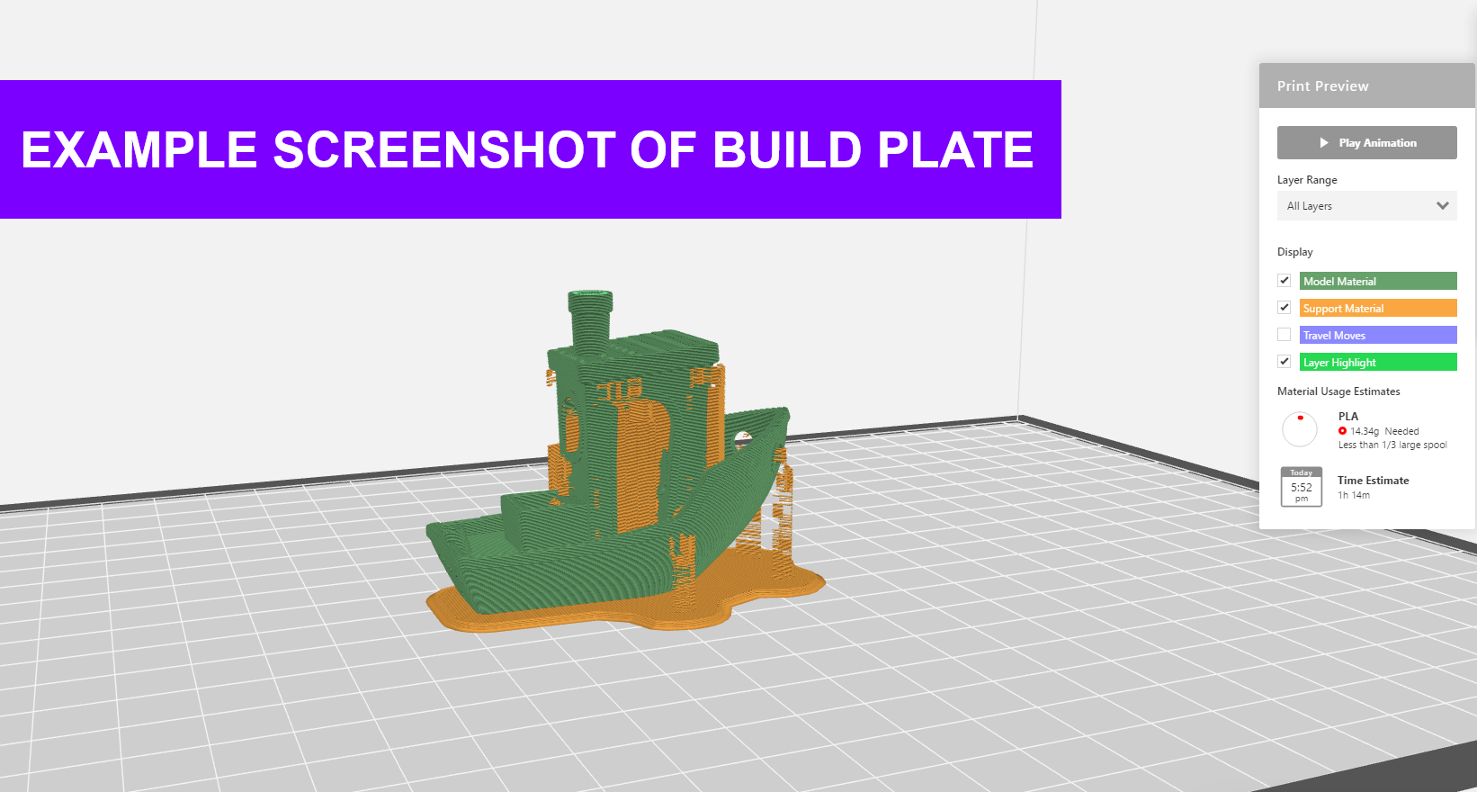

**Before submitting your 3D print jobs to the MakerBot Innovation Centre, please ensure you have done the following:**

|  |
| --- |
| Exports |
| Collection of .stl files for all models on the build plate/s is supplied.  A .makerbot file for each build plate is supplied.  A PDF of this filled out form has been saved and uploaded. |
| **Settings** |
| The supplied .print template has been used to populate the build plate.  Breakaway supports has been selected before export.  Overhangs have been reduced as much as possible.  Any cylindrical models are oriented vertically, where possible.  All models are oriented such that the side with the largest surface area sits on the build plate.  Changes to any default print settings have been stated in the “Notes” section of the Innovation Centre. |

For any queries please consult this page or send an email to:

[**3dprint-creatorspace@unimelb.edu.au**](mailto:3dprint-creatorspace@unimelb.edu.au)